Table 1: Global Navigation
Action | Key Combination
Open/close My Apps | 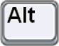 + 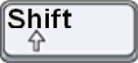 + 
Open/close Help | + + 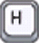
Open/close the App Component Menu | + + 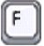
Open/close Store | + + 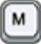
Open/close the App Component Switcher | + + 
Closes the active app component | + + 
Select to the next element | 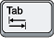
Select to the previous element | +
Activate the selected element | 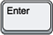
Return to the app component or window header (when inside an app component or window). Esc returns to the OWF Toolbar from anywhere else. To move to the toolbar from a widget header, press Esc. | 

Table 2: Application Navigation
Layout | Key combination | Action
Accordion/  Portal | + + 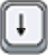 | Expands an app component
Accordion/  Portal | + + 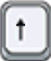 | Collapses an app component
Desktop | + + | Restores collapsed app component or maximizes focused component
Desktop | + + | Minimizes focused app component or resizes maximized component
Desktop, Portal* | 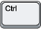 + | Move the focused app component UP
Desktop, Portal* | + | Move the focused app component DOWN

Table 3: Toolbar Navigation
Location | Keyboard Combination
My Apps Window | + +
The Store(s) | + +
Help | + +

This is not a complete list of keyboard navigation shortcuts. Use it as a quick reference of the most popular shortcuts.
Note: The keyboard navigation commands were last updated in OWF 7.0. Therefore, some commands will not work with features that have been updated since 7.0. For example, Tab/Shift + Tab will not select an element inside the My Apps or the App Components menus.

